Aim:
Part A — Practice Programs (Hour 1)
Work these in your lab-NN/ folder before the project: do the first one or two in the lab; the
last (For Advanced Learners) is for home.
1. Shape areas: an abstract Shape with abstract area(); subclasses Circle, Rectangle,Triangle. Put a mix in a Shape[] and loop once to print each area and the running total, tracking the largest — one loop handling every shape through polymorphism.
2. Payroll: an abstract Employee with abstract monthlySalary(); FullTime (fixed), PartTime (hours × rate) and Intern (stipend), each calling super for the shared name/id. Loop a mixed array to print each salary and the total; use instanceof to add a note only for interns.
3. (For Advanced Learners – home) Model a few media types that each compute a late fee differently and total the fees for a returned batch. Design the hierarchy and rules yourself.

Code Screenshot:
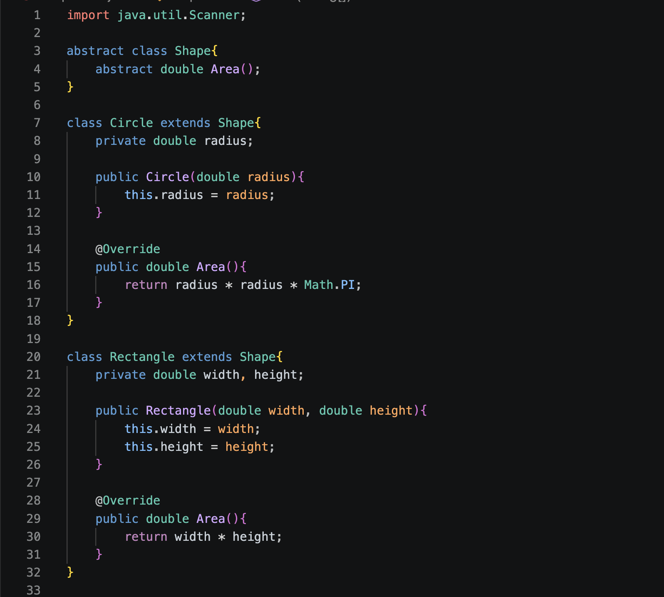
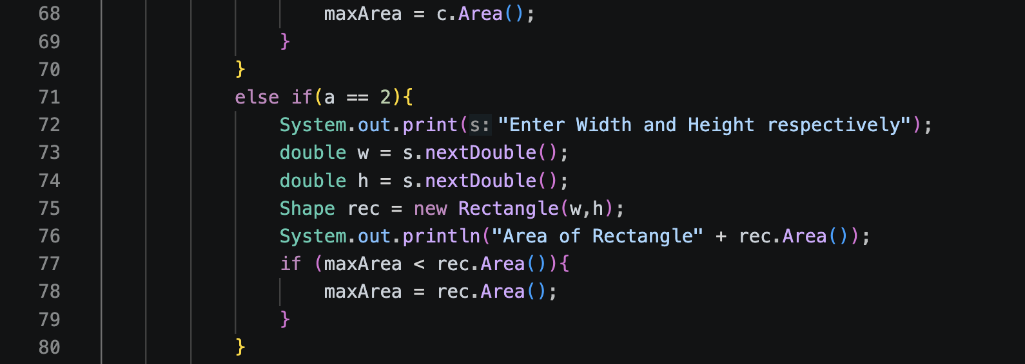

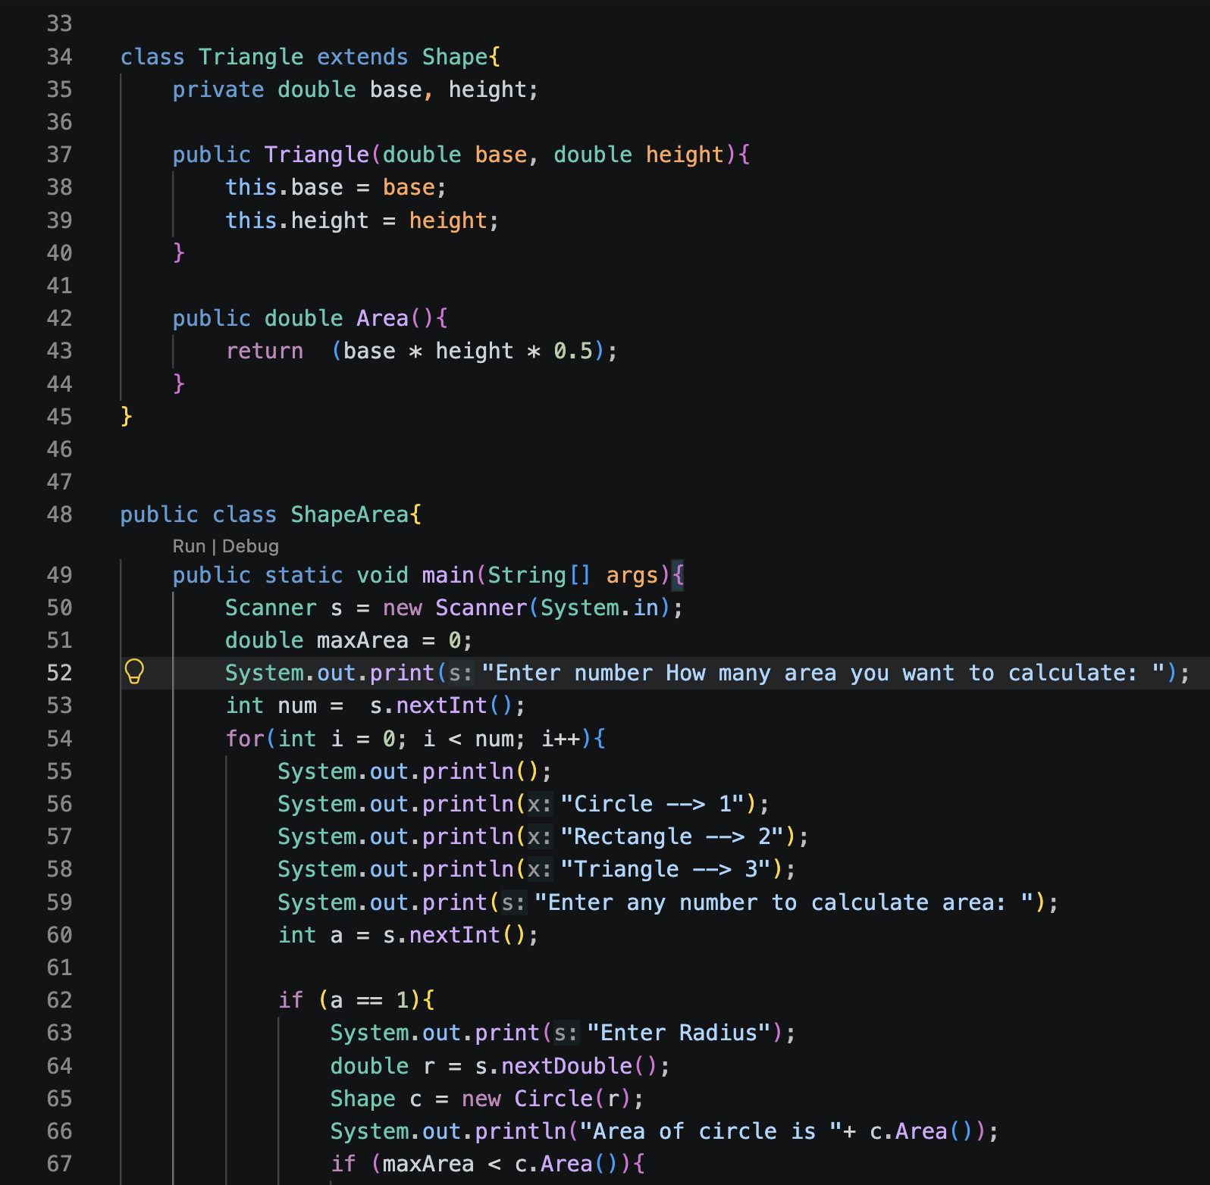
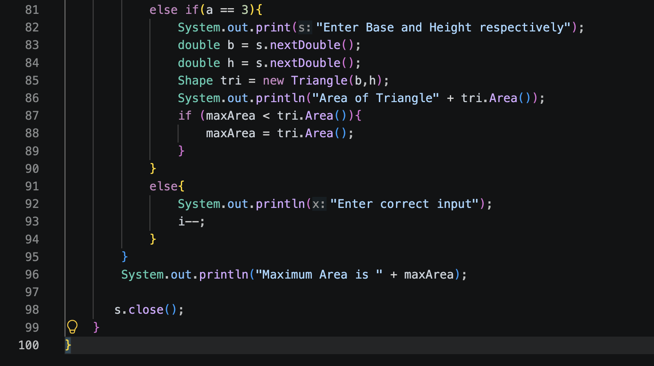
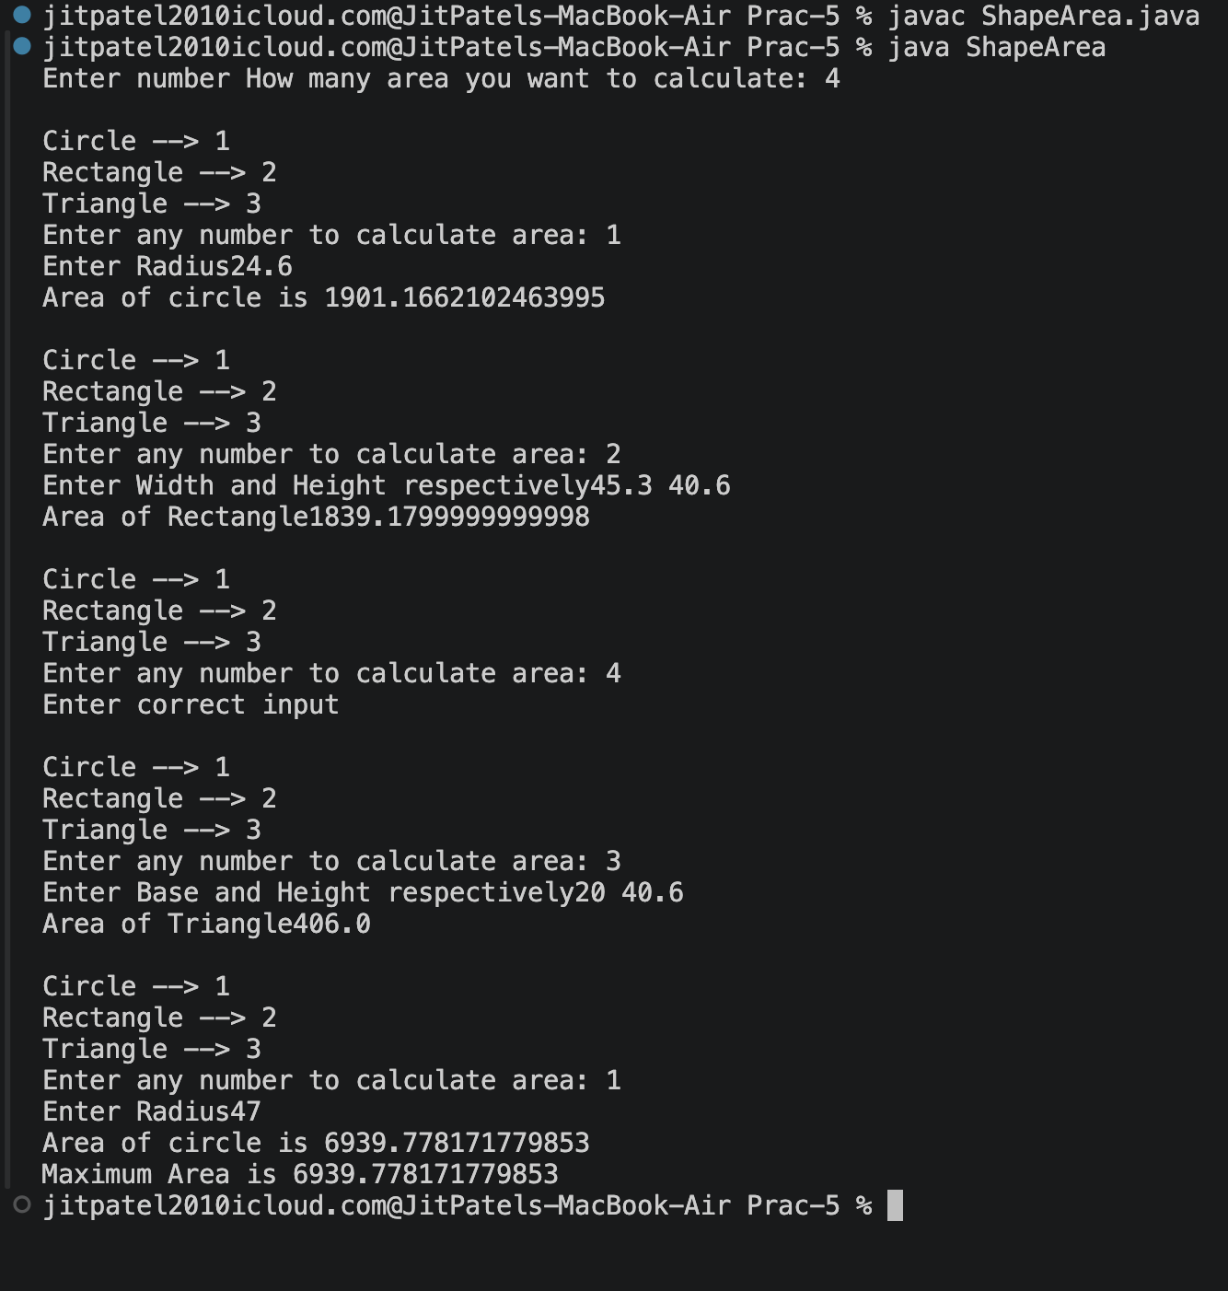
Output Screenshot:

Learning Outcome:

In this practical I understand the abstract class and override methods.

